ROLL NO : 422176

NAME : KOTA VENKATA CHARAN TEJA

SECTION:A

QUESTION:
(week3) :Write shell script for searching for various patterns using grep, pr, head, tail, cut,
paste, sort, uniq, and tr.
GREP.SH
#!bin/bash
echo -e 'grep -i : Ignoring case sensitivity\n';
grep -i "LINUX" text1.txt;
echo -e '\ngrep -c : count of string repetition\n';
grep -c "Linux" text1.txt;
echo -e '\ngrep -w : Exact matching\n';
grep -w "Linux" text1.txt;
echo -e '\ngrep -n : string with its line of repetiton\n';
grep -n "Linux" text1.txt;

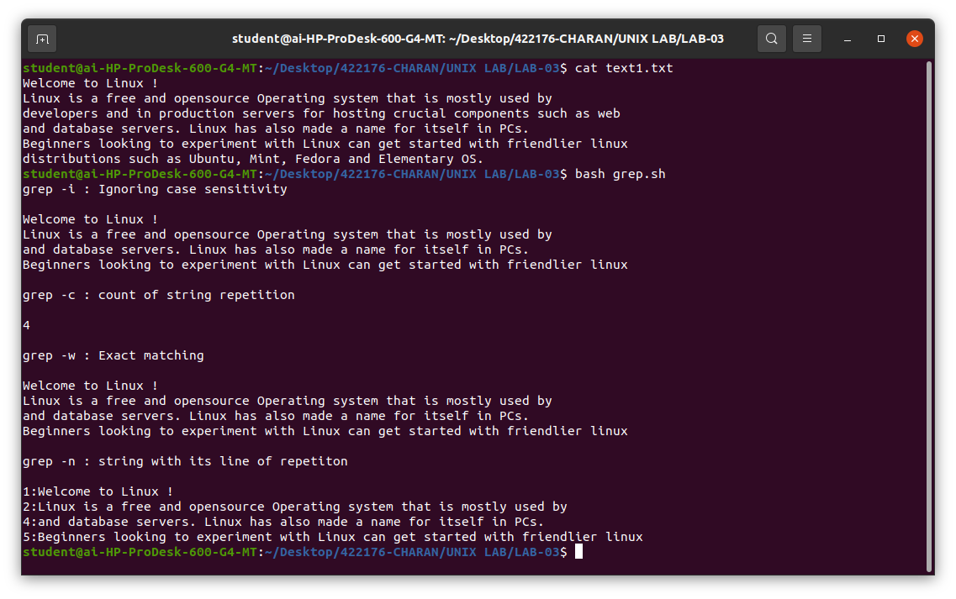
OUTPUT:

PR.SH

#!bin/bash
echo -e "pr text1.txt OUTPUT:\n";
pr text2.txt;
echo -e "\npr -t text1.txt OUTPUT:\n";
pr -t text2.txt;
echo -e "\npr -d text1.txt OUTPUT:\n";
pr -d text2.txt;
echo -e "\npr -5 text1.txt OUTPUT:\n";
pr -5 text2.txt;

OUTPUT:

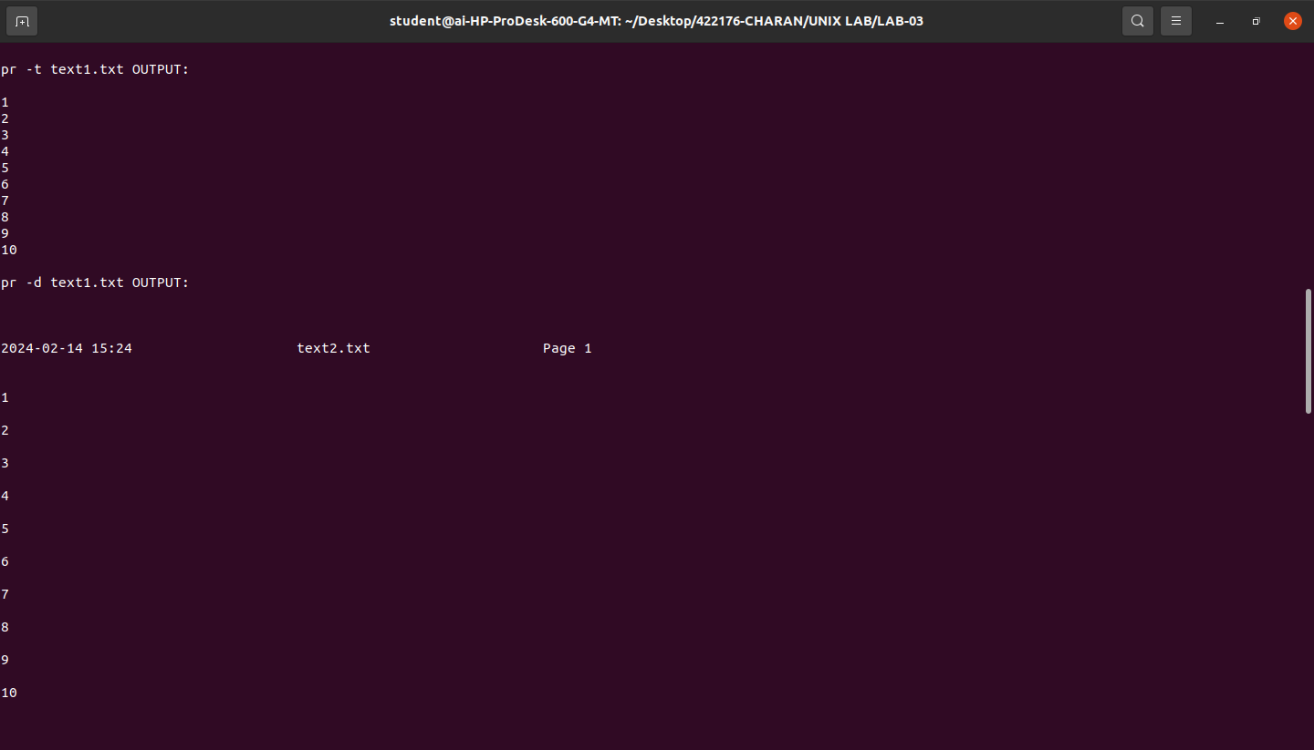
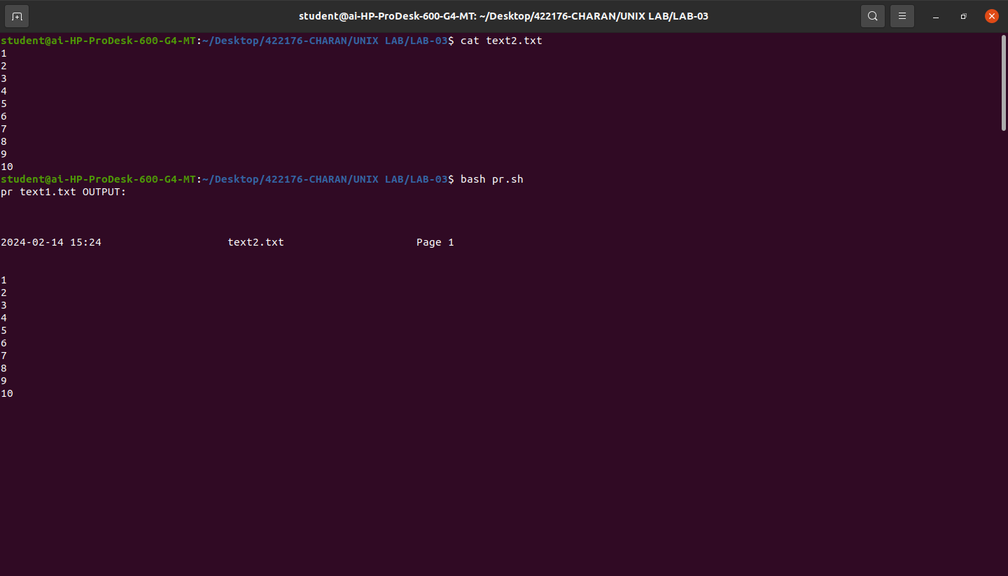

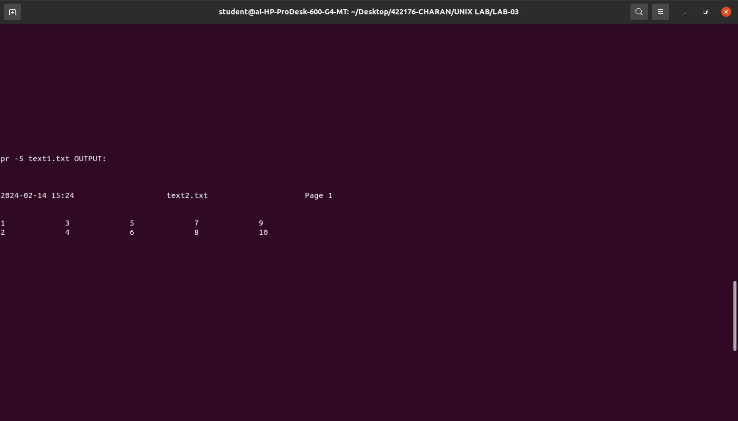

HEAD.sh

#!bin/bash
echo -e "head list1.txt OUTPUT:\n";
head list1.txt;
echo -e "\nhead -n 5 list1.txt OUTPUT:\n";
head -n 5 list1.txt;
echo -e "\nhead -c 50 list1.txt OUTPUT:\n";
head -c 50 list1.txt;
echo -e "\nhead -v list1.txt OUTPUT:\n";
head -v list1.txt;
echo -e "\nhead list1.txt text2.txt OUTPUT:\n";
head list1.txt text2.txt;
echo -e "\nhead list1.txt > name.txt OUTPUT:\n";
head list1.txt > name.txt;

OUTPUT:
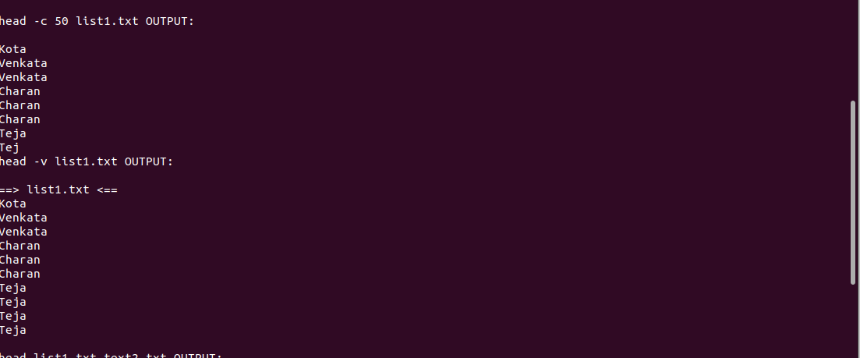

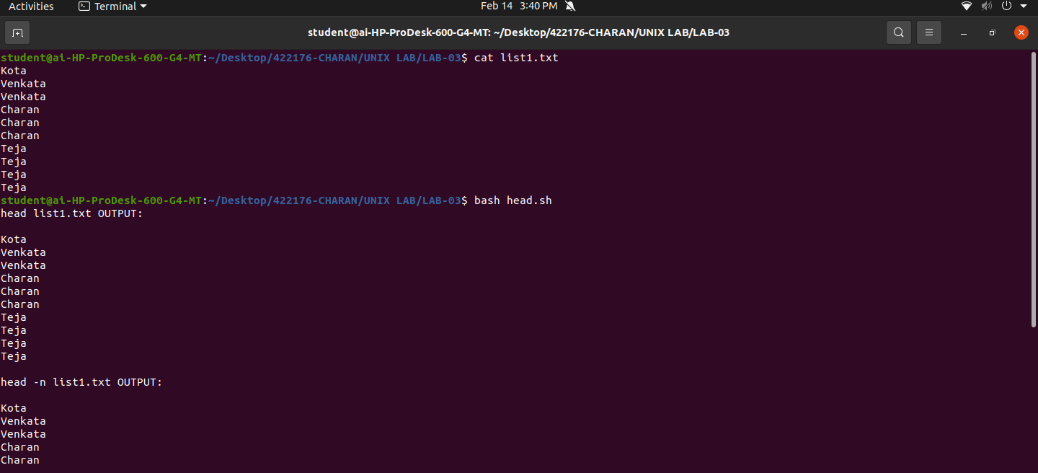
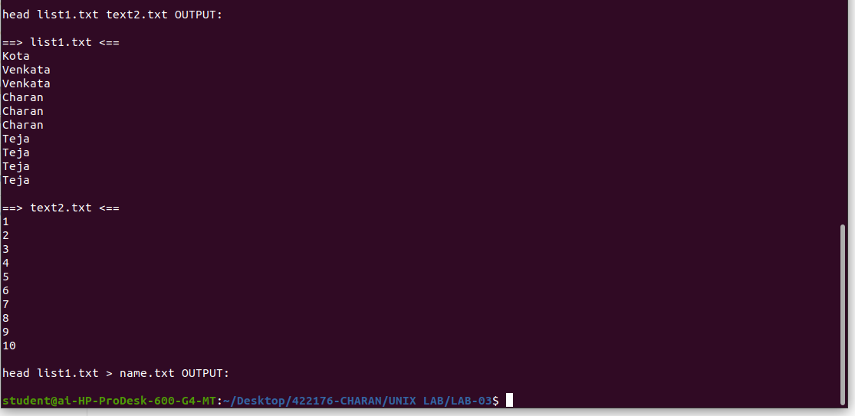
.
TAIL.sh

#!bin/bash
echo -e "tail +5 list1.txt OUTPUT:\n";
tail +5 list1.txt;

OUTPUT:

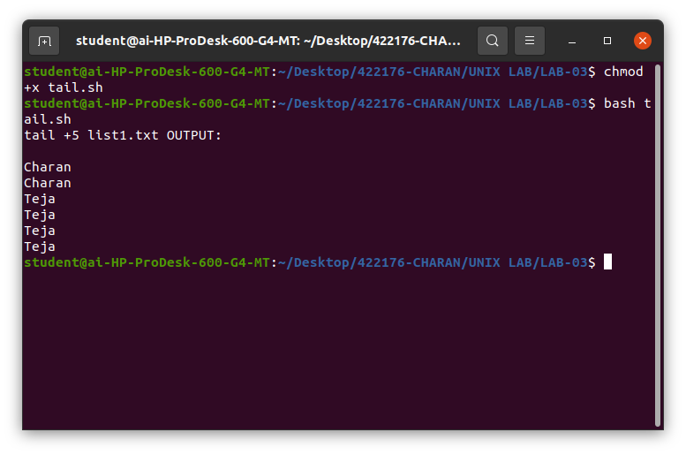
Cut.sh

#!bin/bash
echo -e "cut -b 1,2,3 list1.txt OUTPUT:\n"
cut -b 1,2,3 list1.txt
echo -e "\ncut -b -5 list1.txt OUTPUT:\n"
cut -b -5 list1.txt
echo -e "\ncut -b 3-7 list1.txt OUTPUT:\n"
cut -b 3-7 list1.txt

OUTPUT:

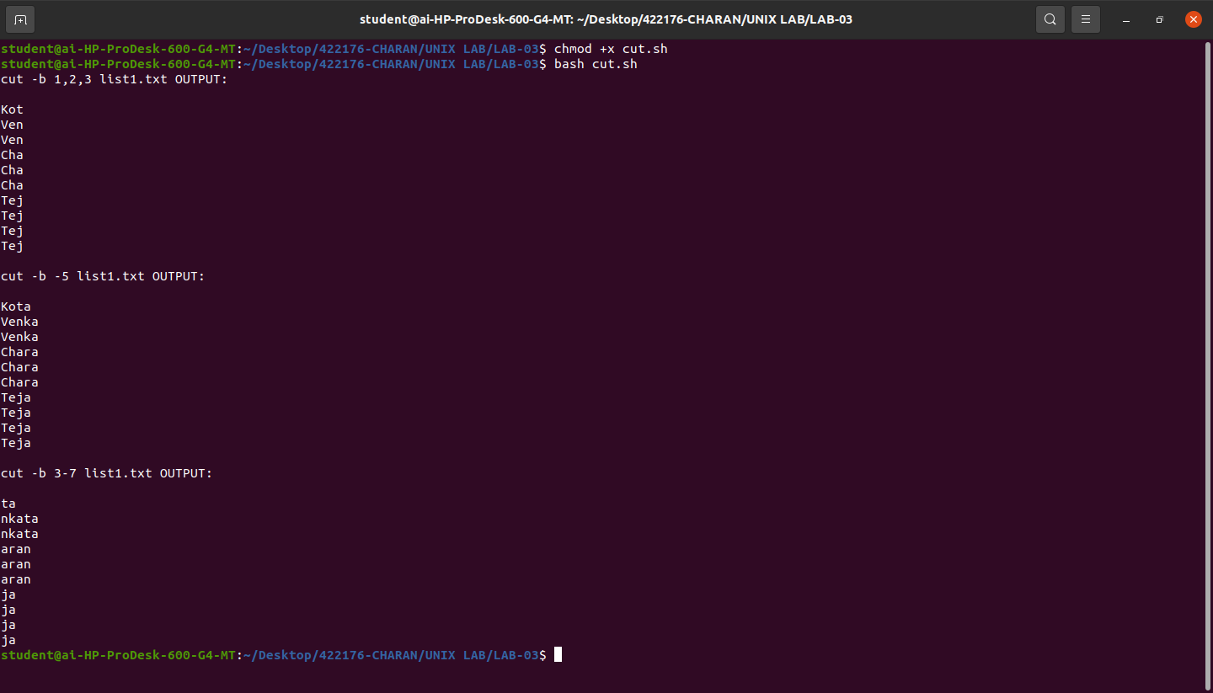
paste.sh

#!bin/bash
echo -e "paste list1.txt text2.txt OUTPUT:\n";
paste list1.txt text2.txt;
echo -e "\npaste -d "|," list1.txt text2.txt text2.txt OUTPUT:\n";
paste -d "|," list1.txt text2.txt text2.txt;
echo -e "\npaste -s -d list1.txt text2.txt text2.txt OUTPUT:\n";
paste -s -d ":" list1.txt text2.txt text2.txt;

OUTPUT:

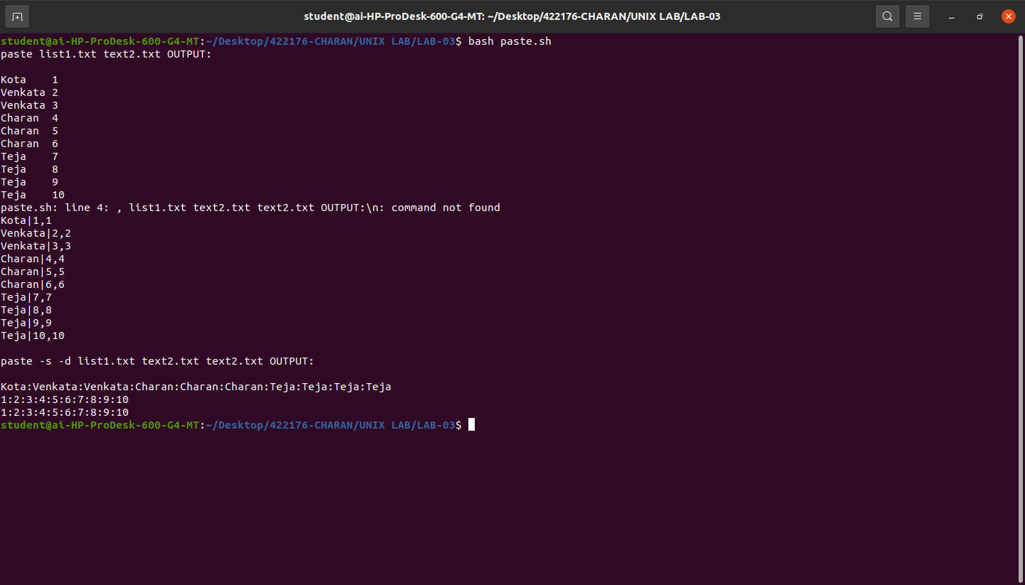
sort.sh

#!bin/bash
echo -e "sort list1.txt OUTPUT:\n";
sort list1.txt;
echo -e "sort -r list1.txt OUTPUT:\n";
sort -r list1.txt;

OUTPUT:

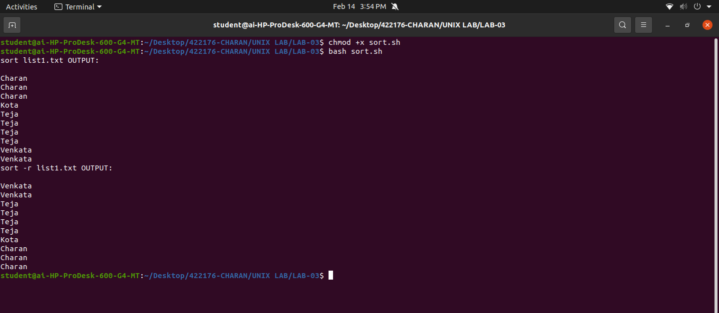
.
uniq.sh

#!bin/bash
echo -e "uniq list1.txt OUTPUT:\n";
uniq list1.txt;
echo -e "\nuniq -c list1.txt OUTPUT:\n";
uniq -c list1.txt;
echo -e "\nuniq -d list1.txt OUTPUT:\n";
uniq -d list1.txt;
echo -e "\nuniq -u list1.txt OUTPUT:\n";
uniq -u list1.txt;

OUTPUT:

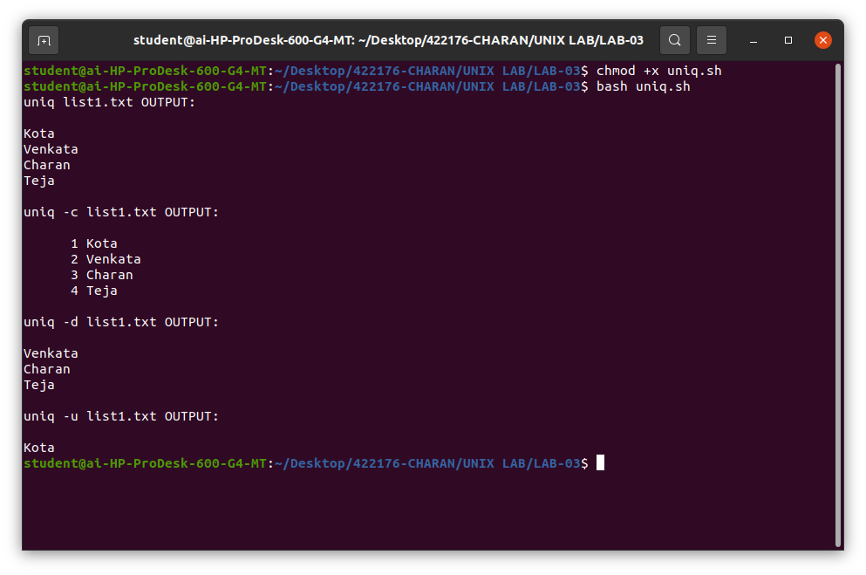
tr.sh

#!bin/bash
echo -e "cat list1.txt | tr [a-z] [A-Z] OUTPUT:\n";
cat list1.txt | tr [a-z] [A-Z];
echo -e "\necho "Hello World!" | tr -d -o OUPTUT:\n";
echo "Hello World!" | tr -d -o;
echo -e "\necho "My Roll no : 422176" | tr -d [:digit:]\n";
echo "My Roll no : 422176" | tr -d [:digit:];

OUTPUT:

